 

ANT Installation & Deployment Guide

**

|  |  |
| --- | --- |
| **File Name** | ANT Installation & Deployment Guide |
| **Version** | 1.0 |
| **Document Owner** | Suresh M |
| **Creation Date** | 01/16/2017 |

**Revision History**

| **Version** | **Revision Date** | **Author(s)** | **Revision Notes** |
| --- | --- | --- | --- |
| V1.0 | *01/17/2017* | Suresh Manukonda | Initial Draft |
| V1.1 | *01/19/2017* | Raushan Anand | Updated comments and document name |

**Distribution of Final Document**

The following people are designated recipients of the final version of this document:

| **Name** | **Organization/Title** |
| --- | --- |
|  |  |
|  |  |
|  |  |
|  |  |

Table of Contents

1. document Overview 4

1.1. Purpose 4

1.2. Scope 4

*1.3.* Audience 4

2. Prerequisites 5

3. installation 5

3.1. Apache Ant installation steps 5

3.2. configure environment variables 6

4. Retrieve meatadata 11

5. deploy meatadata 13



# document Overview

## Purpose

The objective of this document is to provide details on Installation of JDK, ANT and Force.com Migration Tool. It also explains moving metadata between a local directory and a Salesforce org. This document will be used as an input for the developers and deployment specialist to deal with deployment using ANT Tool.

This document is intended to provide the prerequisites, installation, metadata retrieval and deployment steps that are required to move metadata between a local directory and a Salesforce org.

## Scope

This document serves as the guide for metadata deployments using Force.com Migration/ANT tool. Detailed steps are described for installation, configuration and deployment.

## Audience

The intended audience of this document include:

* Deployment – Team or an individual who is responsible for migrating metadata components between the orgs.

# Prerequisites

Ensure to have JDK 1.8 or later version installed.

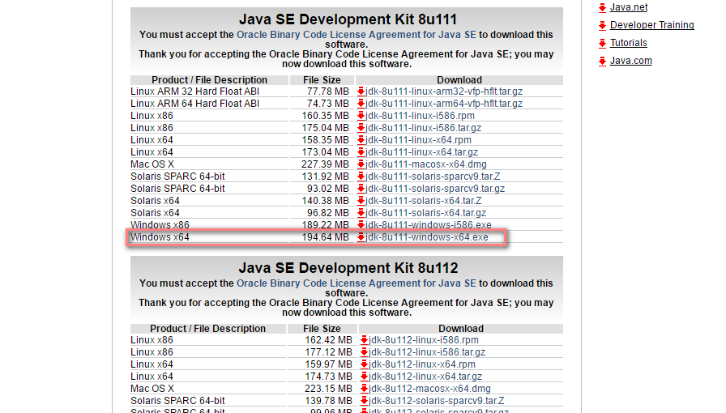

# installation

Install Apache ANT and Force.com Migration tool.

## Apache Ant installation steps

Download Apache Ant version 1.6 or later to a directory of your choice:

<http://ant.apache.org/bindownload.cgi>.

This directory known as ANT_HOME. When the files are on your computer, no further installation is required.

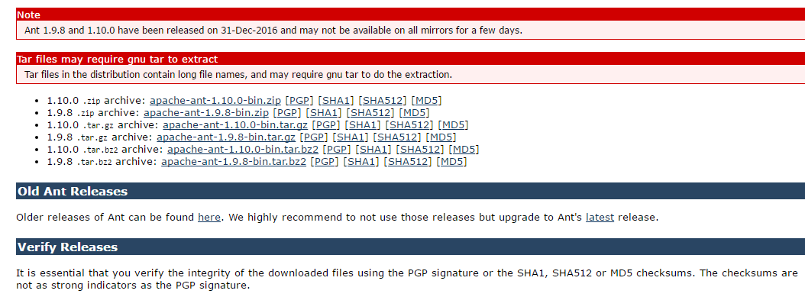

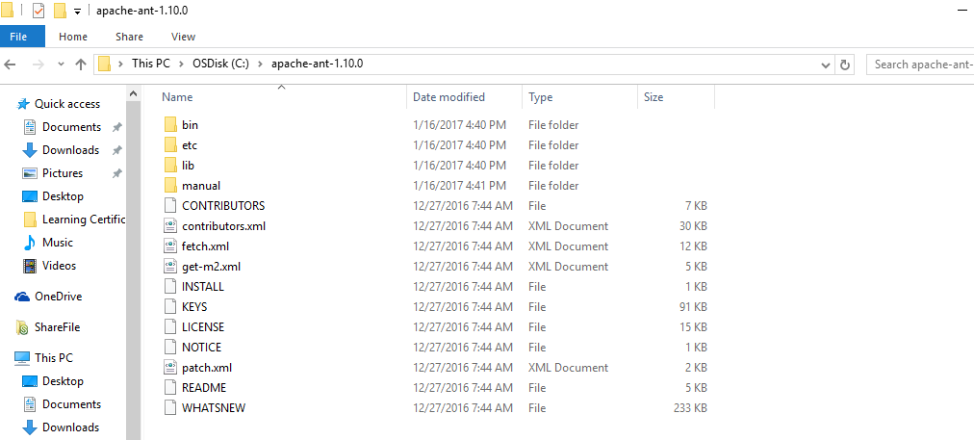

## configure environment variables

If you are using a Windows operating system, create an ANT_HOME environment variable and set the value to where you have installed Ant.

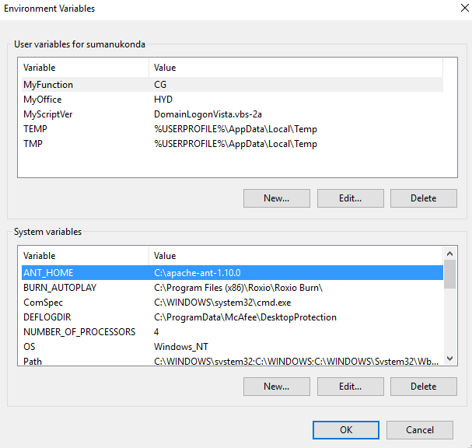

Once JDK is installed, create a JAVA_HOME environment variable and set the value to the location of your JDK.

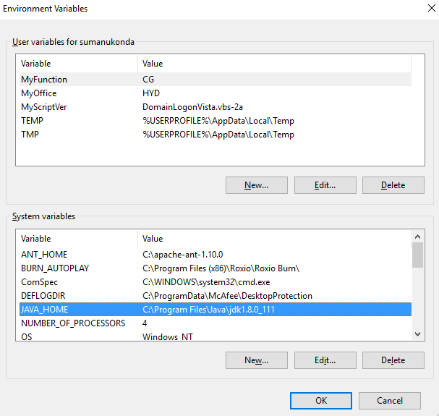

Update PATH system variable by appending %ANT_HOME%\bin at the end, so that you can run the Ant’s command everywhere.

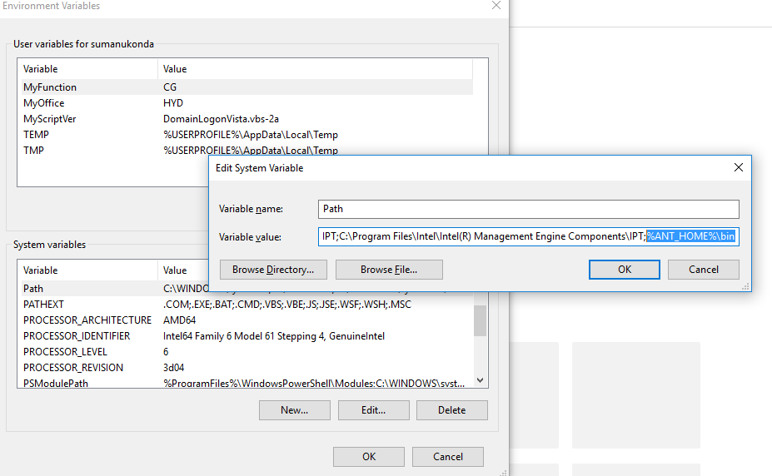

Once environment variables are set and Force.com migration tool is in place, run a command in Command prompt to ensure ANT is installed properly and can be compiled.

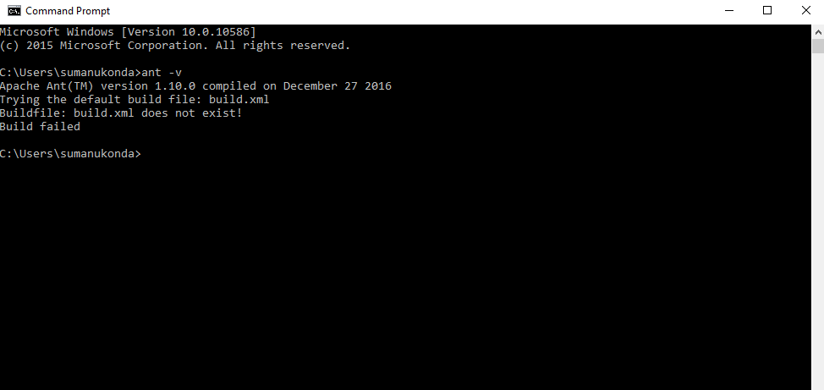

Download Force.com Migration Tool (Salesforce ANT) and place it in a folder of your choice.

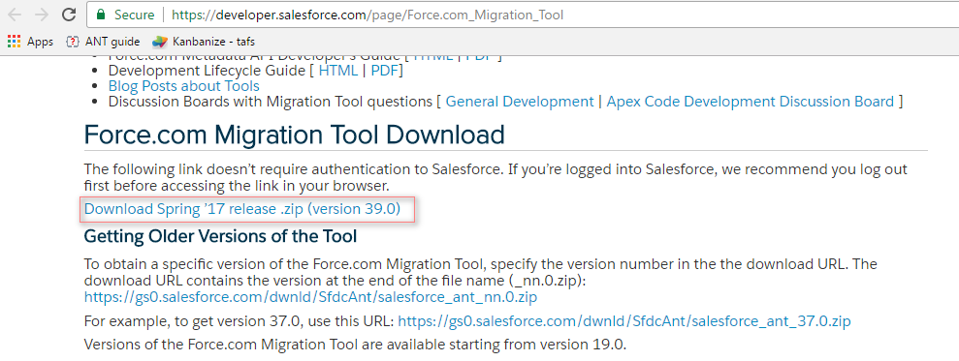

Once download is complete Unzip the file and copy **ant-salesforce.jar** file from Salesforce ANT folder and place it in lib folder of Apache ANT.

**Salesforce ANT folder:**

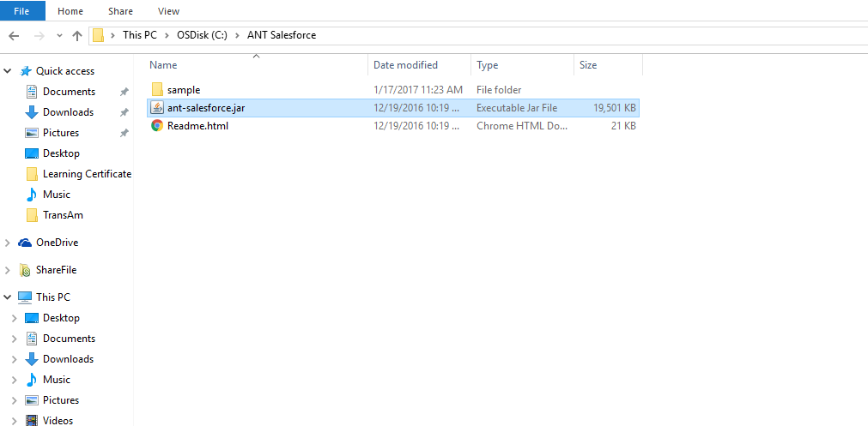

**Lib folder of Apache ANT:**

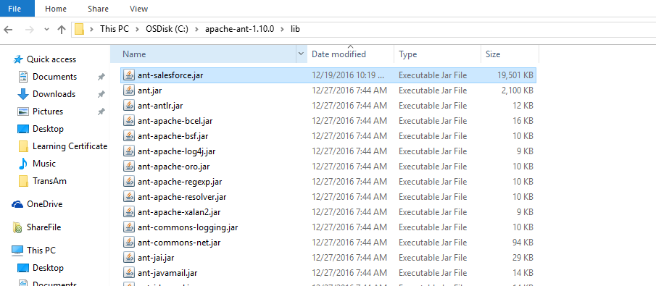

# Retrieve meatadata

Update build.properties file under Sample folder with Username, password and serverurl.

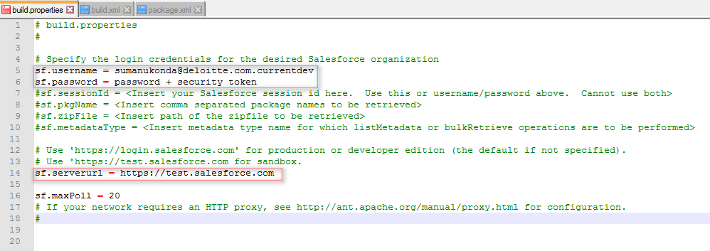

Note: 1. Password must be followed by security token.

Serverurl should be set to <https://test.salesforce.com> in case of Sandbox migration else set to <https://login.salesforce.com> for production migration.

Modify Package.xml based on the components need to be retrieved. In the below screenshot retrieving an apex class, a test class and a trigger.

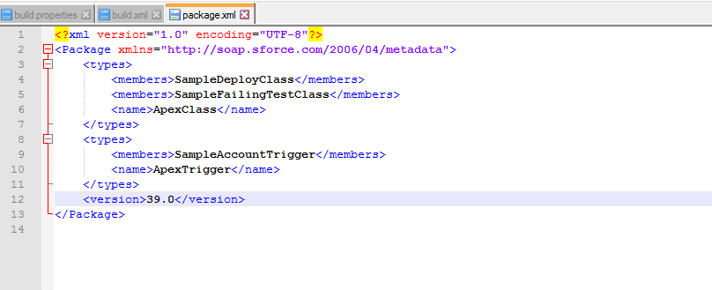

Note: To retrieve all the apex classes or triggers replace the text between corresponding <members> </members> nodes with ‘*’.

Eg: <types>

<members>*</members>

<name>ApexTrigger</name>

</types>

Set the path in Command prompt to the path where the Salesforce ANT jar file exists and run the command ‘**ant retrieveCode**’ to retrieve metadata components into ‘**codepkg**’ folder.

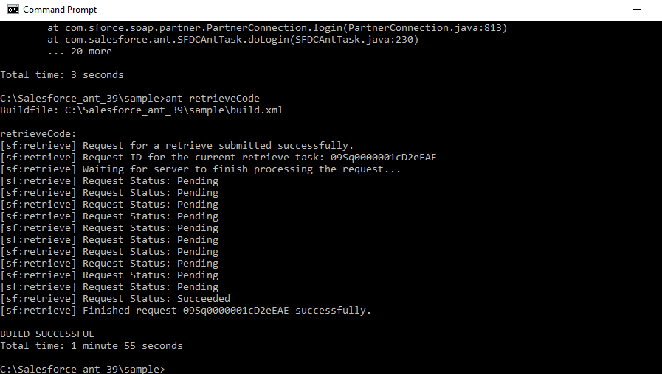

Verify the folder to see the components.

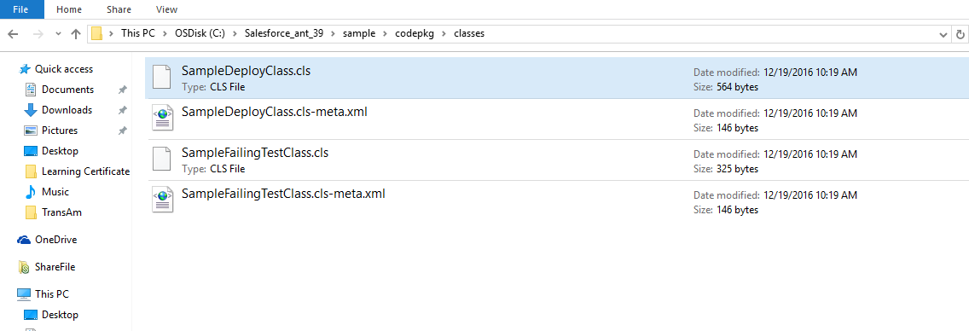

# deploy meatadata

Run the command ‘deployCode’ in command prompt to deploy the code after updating build.xml as below.

deployRoot - Specify the name of the folder where the list of components to be deployed are placed.

testLevel – specify if specified tests to be run or all tests to be run.

